**CENWP-OD-B 07/05/2022**

**MEMORANDUM FOR THE RECORD**

**SUBJECT: 22BON027 PH1 Forebay Gill Net Removal**

On 30 June, Bonneville Fish Biologist noticed a string of buoys in the Bonneville Powerhouse 1 (PH1) Forebay. It was suspected that the string of buoys was attached to a ghost net and was located near the Bradford Island Fishway exit, causing concern for fish safety as well as potential entanglement in PH1 trashracks and Ice and Trash Sluiceway. In the afternoon of 05 July, Bonneville Riggers and a Fish Bio were able to retrieve the ghost gill net via rigger boat. The net was removed and inspected for identification and any remaining fish. No fish were found and the markings “5995 YAK” were found on one of the buoys.

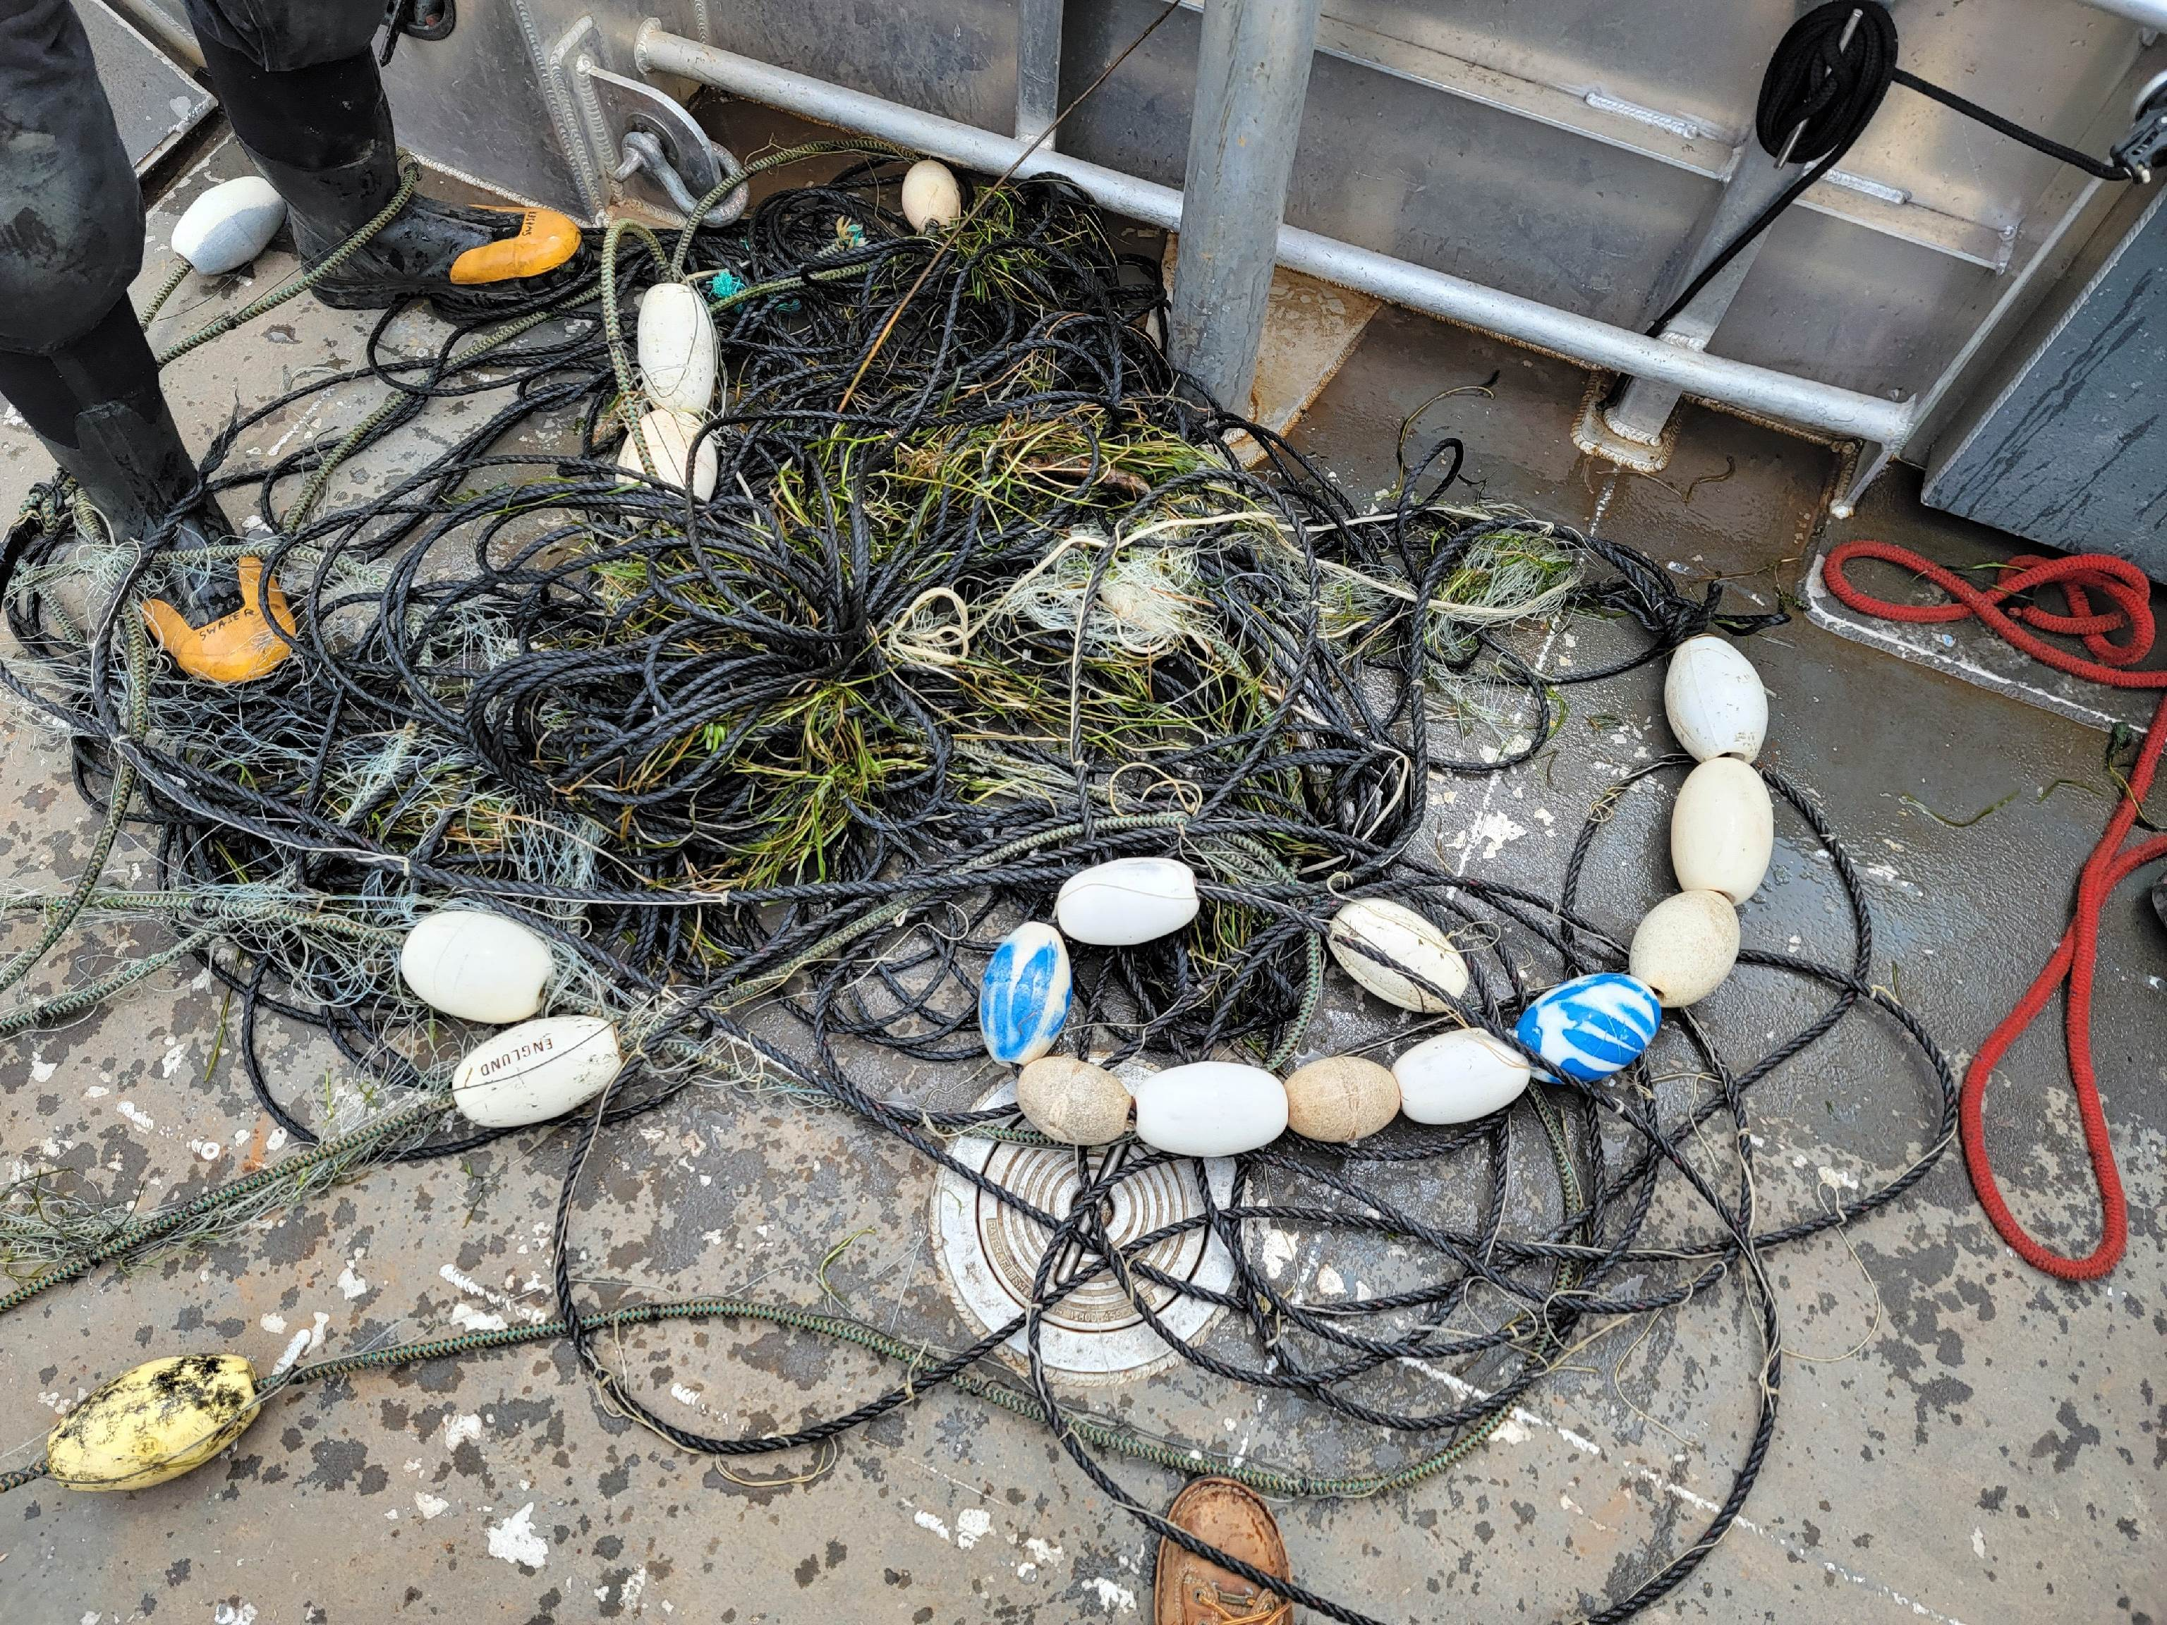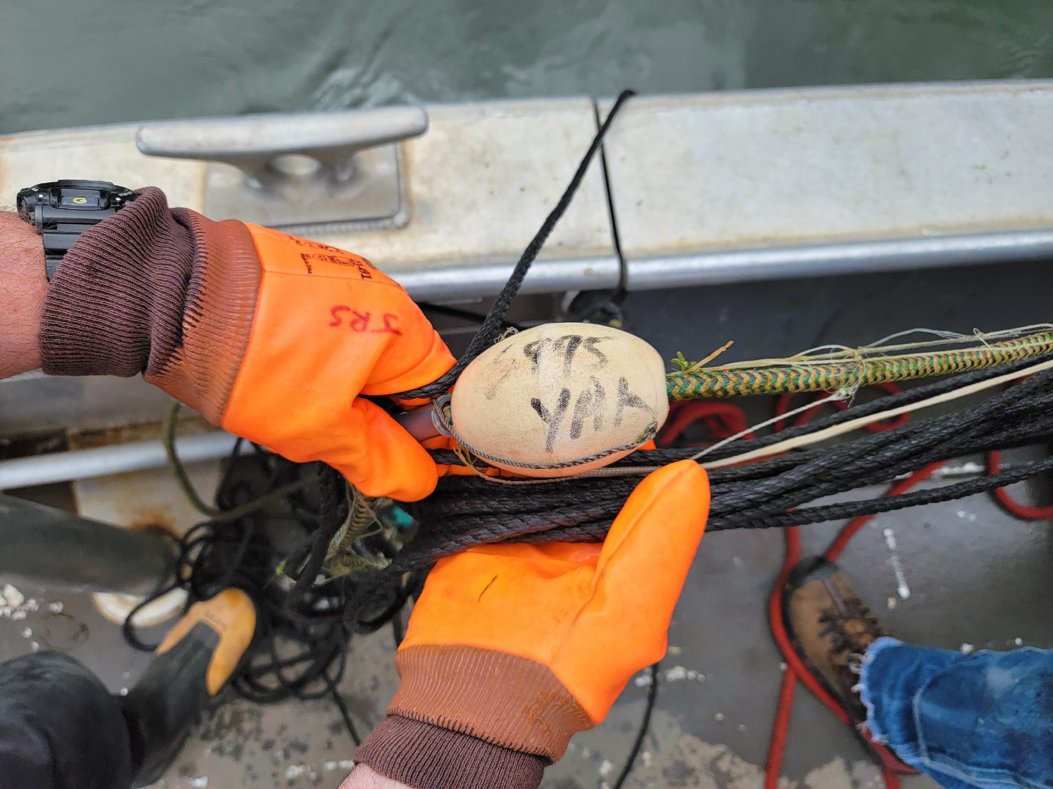

1. Species – N/A
2. Origin – N/A
3. Length – N/A
4. Marks and tags – N/A
5. Marks and Injuries found on carcass – N/A
6. Cause and Time of Death – N/A
7. Future and Preventative Measures – proper anchorage and removal of all gill nets used upstream.

Sincerely,

Project Fisheries